

**Learning Strengths and Styles**

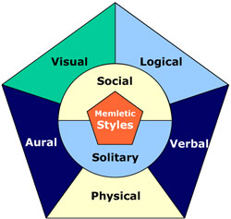

**Technology Unit of Instruction**

**Table of Contents**

Overview of Technology Plan of Instruction3

Instructional Goal3

Intended Audience4

Length of Instructional Unit5

Performance Objectives5

Standards Covered5

Delivery Approach/Instructional Strategies6

Constructive Instructional Strategies7

Instructional Sequence8

Needed Materials9

Unit Overview9

Lesson One: 10

Lesson Two: 11

Lesson Three: 12

Lesson Four: 13

Lesson Five: 14

Lesson Six: 15

Learner Assessment16

Rubric I Note Taking16

Rubric II Oral Presentation17

Rubric III Brainstorming Presentation18

Rubric IV Class Blog Writing19

Instructional Materials20

Bubbl.Us Sample20

Howard Gardner Theory of Multiple Intelligences21

100 Helpful Webtools for Every Type of Learner24

Resources Cited29

**Overview of Technology Plan of Instruction**

The purpose of this unit of instruction is to give students the tools necessary to learn and retain information. Many students fail to realize the best methods of learning information. Howard Gardner developed the theory of multiple intelligences. Gardner believed that people have a variety of learning strengths and styles. Gardner claimed that, “students possess different kinds of minds and therefore learn, remember, perform, and understand in different ways," (Gardner 1991). According to this theory, "we are all able to know the world through language, logical-mathematical analysis, spatial representation, musical thinking, the use of the body to solve problems or to make things, an understanding of other individuals, and an understanding of ourselves.” Gardner’s theory is the basis for the creation of this unit of instruction.

Students in the average middle school class are unable to retain information and they are unable to transfer learning to other situations. Students seem unaware of what information is important, how to take useful notes, and how information should be organized for optimal recovery and review. These are skills that need to be taught and implemented in order to help our students perform at the level required to compete in today’s global market economy.

Today’s students are surrounded by technology and are easily distracted. Learning about how they learn best can be beneficial to students wanting to improve their retention and recall of important information. Knowing how to learn and how to study will produce a generation of better learners.

**Instructional Goals**

Given instruction on learning styles students will be able to identify their learning strengths. Knowing their learning strengths will allow students to organize their instruction, use their learning strengths, and retain information. Given instruction on collaborative writing students will write about the learning process, explore their learning strengths, and respond to the writings of others.

**Intended Audience**

The intended audience is middle school students grades sixth, seventh, and eighth grade. However, this unit could easily be adapted for high school students or pre-service teachers.

Students range from 11 to 14 years of age. Students are familiar with writing research papers although their abilities vary. Several of the sixth grade boys have a difficult time organizing their thoughts and writing a thesis statement. The seventh and eighth grade girls are very motivated to write and learn and they will be used as mentors to the less motivated learners. All of the students are adept at Internet use. The boys are gifted at multimedia presentations especially with animating Keynote presentations. The girls enjoy making iMovies and experimenting with variety of movie styles. Students enjoy using a variety of technologies although sometimes they use them inappropriately. Students are adept at multitasking, although sometimes they use their time unwisely.

The school is project based and students are not sorted into classes by age, but have a variety of ages and ability levels in each class. This allows for older students to mentor younger students and for students to gain skills in a student-centered environment. The advisory class is 25 students, so we will have five groupings of five students each.

Advisory is a project and research based class where students fulfill requirements such as World Geography, US History, Social Studies, etc. Knowledge about learning strengths and skills will build understanding and benefit this population. This can be transferred to other students within this learning environment. This school also has a strong emphasis on technology integration so it will be beneficial for students to learn which technologies will best help them learn and keep track of information.

**Length of Instructional Unit**

This unit of instruction is best covered in two weeks of instruction. Spreading the seven lessons over a period of two weeks allows students time to research, blog, and present. Each lesson is meant to cover a class period of 90 minutes allowing for additional work to be completed as homework by the students.

**Performance Objectives**

* Performance Objective 1.1: After completing the survey, students will be able to identify three methods of learning they excel in with 100% accuracy.
* Performance Objective 2.1: Given the information obtained in their research, students will collaborate with peers to create a 5-minute multimedia presentation according to the rubric.
* Performance Objective 3.1: Given the instruction on the use of Notability students will organize notes using Notability and create notes on their main learning style and strength.
* Performance Objective 4.1: Given the presentations of the other groups, students will take notes on the different learning styles identifying each of the seven learning styles with 100% accuracy.
* Performance Objective 5.1:Given the tools provided, students will use a multimedia technique to create a learning map with 100% accuracy.
* Performance Objective 6.1: Given the criteria, students will write a one paragraph answer to the question prompts, post it on the class blog, and respond to the postings of two classmates.

**Standards Covered**

Common Core State Standards Grade 6 - 8

Writing Standards for Literacy in History/Social Studies, Science, and Technical Subjects

**Production and Distribution of Writing**

4. Produce clear and coherent writing in which the development, organization, and style are appropriate to task, purpose, and audience.

5. With some guidance and support from peers and adults, develop and strengthen writing as needed by planning, revising, editing, rewriting, or trying a new approach, focusing on how well purpose and audience have been addressed.

6. Use technology, including the Internet, to produce and publish writing and present the relationships between information and ideas clearly and efficiently.

**Research to Build and Present Knowledge**

7. Conduct short research projects to answer a question (including a self-generated question), drawing on several sources and generating additional related, focused questions that allow for multiple avenues of exploration.

**Delivery Approach and Instructional Strategies**

Meaningful learning is interrelated, interactive, and interdependent. That is, learning and instructional activities should engage and support combinations of active, constructive, intentional, authentic, and cooperative learning. (Howlett, Jonassen, Marra 2012) Students will participate in a variety of tasks. Some tasks will require collaboration with other students. Other tasks require students to write and reflect on their learning process. Each lesson begins with review of previous knowledge. This builds pathways to previous learning.

The instructor is the facilitator and not the teacher for this unit of instruction. Prior to beginning this unit of instruction there are several templates that need to be set up on Google Drive and a Classroom Blog will need to be created. All students will need access to the class blog and the teacher needs to monitor all blogs prior to posting unless all of your students can be trusted to post and comment appropriately.

The students will be responsible for researching the various types of learning styles and presenting these to the class. The instructor’s role is to guide discussions, monitor and respond to blog writings, guide students’ progress and then evaluate whether mastery has taken place. Allowing students to build on previous knowledge, conduct active research, and construct their understanding from their own work and the work of others is one of the guiding principles of a Constructivist classroom.

**Constructive Instructional Strategies**

* Constructivist teachers encourage and accept student autonomy and initiative.
* Constructivist teachers use raw data and primary sources, along with manipulative, interactive, and physical materials.

# When framing tasks, constructivist teachers use cognitive terminology such as "classify," "analyze," "predict," and "create."

# Constructivist teachers allow student responses to drive lessons, shift instructional strategies, and alter content.

# Constructivist teachers inquire about students' understandings of concepts before sharing their own understandings of those concepts.

# Constructivist teachers encourage students to engage in dialogue, both with the teacher and with one another.

# Constructivist teachers encourage student inquiry by asking thoughtful, open- ended questions and encouraging students to ask questions of each other.

# Constructivist teachers seek elaboration of students' initial responses.

# Constructivist teachers engage students in experiences that might engender contradictions to their initial hypotheses and then encourage discussion.

# Constructivist teachers allow wait time after posing questions.

# Constructivist teachers provide time for students to construct relationships and create metaphors.

* Constructivist teachers nurture students' natural curiosity through frequent use of the learning cycle model. (Brooks & Brooks, 1993)

**Instructional Sequence**

### The sequencing of instruction will follow a discovery of learning styles and using the techniques learned in each lesson. Students will first discover what learning styles are. Once they have a brief overview of the styles they will explore the free resource: <http://www.learning-styles-online.com>. Students will take this online assessment to learn what their specific strengths in learning are. The second lesson will pair students into heterogeneous groupings where they will collaborate with their classmates to create a brief multimedia presentation describing in depth one learning style. The third lesson teaches the students about creating notes that are meaningful and useful for them. The purpose of moving this lesson on Notability as the third lesson is so that students can take useful notes from each group presentation. Lesson four is the group presentation on the various learning styles. With the Notability learning of the previous day, students will be able to take notes on each presentation in a way that is meaningful for their learning abilities. Lesson five is a lesson on various types of note creation and brainstorming. In this lesson students will have the opportunity to explore other types of note taking and brainstorming software or webtools. They will briefly share their examples with their classmates. The final lesson allows students to explain the learning process that has taken place and allows them to elaborate on the experiences of the unit of instruction. Students will analyze what they have learned about their own learning styles and they will have the opportunity to respond to the analysis of other students.

**Needed Materials**

## Internet access

### <http://www.learning-styles-online.com>

### <http://bubbl.us>

* [www.collegeathome.com/blog/2008/06/10/100-helpful-web-tools-for-every-kind-of-learner/](http://www.collegeathome.com/blog/2008/06/10/100-helpful-web-tools-for-every-kind-of-learner/)

### Google search engine

* Edublog Class Blog
* http://pickapeck.edublogs.org/2013/03/24/what-is-your-learning-style/

## iPads

### Keynote

### Pages

### Notability

### iMovie

## Television

## Apple TV

* + - * + If you don’t have an Apple TV a Smartboard and a Projector would work with an iPad

## Whiteboard

### Expo Markers

## Poster boards

### Markers

### Paints, Bingo Daubers

**Unit Overview**

Students in the average middle school class are unable to retain important information to transfer learning to other situations. Students also seem unaware of what information is important, how to take useful notes, and how information should be organized for optimal recovery and review. These are skills that need to be taught and implemented in order to help our students perform at the level required to compete in today’s global market economy.

Today’s students are surrounded by technology and are easily distracted. Learning about how they best learn can be beneficial to students wanting to improve their retention and recall of important information. Knowing how to learn and how to study will produce a generation of better learners.

**Lesson One Student Engagement Investigation: Learning Styles**

Lesson Objective: Students will learn about a variety of learning styles and identify their learning strengths.

Performance Objective 1.1: After completing the survey, students will be able to identify three methods of learning they excel in with 100% accuracy.

***Step 1: Pre-instructional activities****:* Introduction to Learning Styles and Strengths.

Popcorn session: using a small squishy ball have students catch the ball and tell what type of a learner they think they are… This is done prior to introducing any of the seven types of learners, so student’s responses may not be accurate. If students aren’t certain of types of learning strengths have them list a learning strength such as reading, drawing, music, etc. Give each student the opportunity to answer once.

**Motivation of the learner**

What types of learners are there? How often do you hear someone say, “I just don’t get math, I don’t remember that formula?” Did you know that each of you has the ability to learn? Everyone has different strengths and learning abilities, but in order to retain and recall information, we need to discover the pathways that will help us locate and recall information.

***Step 2: Content presentation***

You Tube Video: Find Out Your Learning Style by GBC Student Workshops

***Step 3: Learner Participation:***

This video has given you a brief overview of the four main types of learning. Most of us have some idea of how we learn best, but we are going to take an online assessment so that you can evaluate how you learn best.

* Open your iPad, and go to your safari browser. Type in the following link: <http://www.learning-styles-online.com>
* Take the assessment then read about your top three learning styles.

***Step 4: Assessment***

Using your notability app write down your assessment results for each of the seven learning styles. List one learning technique for your top learning style(s). E-mail them to the instructor.

**Lesson Two Group Project Research**

Lesson Objective: Students will collaborate on research and create a 5-minute presentation.

Performance Objective 2.1: Given the information obtained in their research, students will collaborate with peers to create a 5-minute multimedia presentation according to the rubric.

***Step 1: Pre-instructional activities****:* Recalling Learning Styles and Strengths.

Working as the scribe, have students create a list of the seven learning styles on the board. Under each learning style have students give one technique or strength those types of learners may have. Use random assignment to call students to write these on the board.

**Motivation of the learner**

Using their Notability or whiteboard app students should write their top learning style/ strength. Without discussing these with other students, each student will hold this up for the instructor to see. Students will then stand and be placed by the instructor into seven groups. There should be 3 to 5 students per group. The important part of this is to have a variety of learners in each group.

***Step 2: Content presentation***

## Each group will choose a learning style from the board.

### Each group will choose a group name.

* + Assign one member of the group to be a team leader.
    - The team leader will be in charge of:
      * Making sure that each member of the group participates.
      * Assigning each member of the group a responsibility.
      * Following the rubric.
      * Keeping the group working on a multimedia presentation.

### Record group names and learning style assignments.

Students may use the website provided yesterday: <http://www.learning-styles-online.com> as it explains each of the learning style strengths and techniques. Students may also use reliable on-line resources other than Wikipedia to answer their question.

***Step 3: Learner Participation:***

### Research Learning Styles – Identify:

### Learning strengths

### Learning challenges

### Best way to retain information

### Best way to record notes

## Group Multimedia Presentation Creation

* Each group will choose either a keynote, iMovie, Podcast, etc., to teach the class about their assigned learning style

***Step 4: Assessment:***

Observe students as they are participating with the group collaboration activities. Meet with each group to ensure that each member is assisting with part of the work.

**Lesson Three Notability Note Taking**

**Lesson Objective:** Students will explore Notability and teach the class about one feature of Notability.

Performance Objective 3.1: Given the instruction on the use of Notability students will organize notes using Notability and create notes on their main learning style and strength.

***Step 1: Pre-instructional activities****:*

Bring the class together in a circle. Bring the squishy ball and have the students pass the ball and give one item they learned during their research yesterday. Explain that today they will be learning how to use Notability to record notes, create mind maps, outlines, etc.

***Step 2: Content presentation***

View the YouTube video Intro to Notability: <http://www.youtube.com/watch?v=J9O0b5ukIxk>

Lead the class in a discussion of how Notability can be used to create meaningful notes for each type of learner.

***Step 3: Learner Participation:***

Allow the students to choose one person to work with or they may work individually on this. Have each group of two choose a note subject from the Ginger Labs website or one of the YouTube videos from Ginger Labs the creator of Notability. Each group will spend 25 minutes learning about this feature of Notability. Using their iPad and the Apple TV each group will show the class what they have learned to use on Notability in a short 2 to 3 minute presentation.

* Use the timer to keep the 25 minutes of research and each presentation to a maximum of 3 minutes.

Put the following URL on the board: <http://support.gingerlabs.com/>

#### [Can I move my handwriting?](http://support.gingerlabs.com/customer/portal/articles/273947-can-i-move-my-handwriting-)

#### [Can I insert, delete or clear a page?](http://support.gingerlabs.com/customer/portal/articles/273945-can-i-insert-delete-or-clear-a-page-)

#### [Can I rearrange pages?](http://support.gingerlabs.com/customer/portal/articles/327633-can-i-rearrange-pages-)

#### [How do I change the name of a note?](http://support.gingerlabs.com/customer/portal/articles/270396-how-do-i-change-the-name-of-a-note-)

#### [How do I copy a note?](http://support.gingerlabs.com/customer/portal/articles/329952-how-do-i-copy-a-note-)

#### [How do I delete a recording?](http://support.gingerlabs.com/customer/portal/articles/275466-how-do-i-delete-a-recording-)

#### [Can I insert a text box?](http://support.gingerlabs.com/customer/portal/articles/275480-can-i-insert-a-text-box-)

#### [What does left-handed mode do?](http://support.gingerlabs.com/customer/portal/articles/412542-what-does-left-handed-mode-do-)

#### [Are audio recordings linked to notes?](http://support.gingerlabs.com/customer/portal/articles/723488-are-audio-recordings-linked-to-notes-)

Ginger Lab YouTube Videos: <http://www.youtube.com/user/GingerLabsInc?feature=watch>

* Notability 4 - Customizable Toolbar <http://www.youtube.com/watch?v=1UTTWZSQ4cY>
* Notability 4 Handwriting <http://www.youtube.com/watch?v=vhr7fN5_UTA>

# Notability 4 - PDF Import & Annotation <http://www.youtube.com/watch?v=lTabIv2beSU>

# Notability 4 – library <http://www.youtube.com/watch?v=gmVXanCGUCI>

# Notability 4 – Themes <http://www.youtube.com/watch?v=hr4rkFOYk8k>

* Notability 4 - PDF Import & Annotation <http://www.youtube.com/watch?v=lTabIv2beSU>
* iPad Notability Review <http://www.youtube.com/watch?v=FZ4DX4wDbXk>

***Step 4: Assessment:***

Each group of two will teach the class about one function of Notability.

Rubric for grading student work is attached.

* If there is any time available at the end of the presentations allow students to gather with their group and work on their multimedia presentations for tomorrow.

**Lesson Four Group Multimedia Presentations**

**Lesson Overview**: Students will teach the class about learning styles and identify learning strategies.

**Lesson Objectives:** Students will be able to understand their learning strengths.

Students will gain skills to help them retain and recall information that is taught.

Performance Objective 4.1: Given the presentations of the other groups, students will take Notability notes on the different learning styles identifying each of the seven learning styles.

***Step 1: Pre-instructional activities****:*

Think-pair-share: have each student turn to their table partner and share their main learning style and one learning strength. Have student volunteers come up and share a learning style and one learning technique that works for that learning style. Each learning style should be shared and review should last 5 to 10 minutes. (Set a timer if necessary)

**Motivation of the learner**

Allow the students to collaborate for ten minutes to organize who will speak during each part of the presentation.

***Step 2: Content presentation***

## Note Taking Requirements

### Write down three learning strengths for each type of learner

### What types of note taking or study techniques are best for each type of learner to retain information.

***Step 3: Learner Participation:***

## Group Presentations

### Visual – Spatial

### Auditory – Aural

### Verbal – Linguistic

### Physical – Kinesthetic

### Social – Interpersonal

### Solitary – Intrapersonal

### Logical – Mathematical

***Step 4: Assessment:***

Each group will present their learning style results to the class. Students will be graded on a presentation rubric. Each presentation should be between 3 and 5 minutes. A timer may need to be set so that all 7 presentations can be given before the end of class.

## Turn in Group Presentations and Notes

* Write the homework assignment on the board and have the class record this in their agenda or notes.

Homework:

* Read the College@Home Blog: 100 Helpful Web Tools for Every Kind of Learner.

[www.collegeathome.com/blog/2008/06/10/100-helpful-web-tools-for-every-kind-of-learner/](http://www.collegeathome.com/blog/2008/06/10/100-helpful-web-tools-for-every-kind-of-learner/)

* Choose one tool which works best for your learning style and decide whether you should create a mind map, podcast, or collaboration technique outlining your learning strengths. This will be our class opening tomorrow, start planning.

**Lesson Five Organization Tools/ Mind Mapping**

**Lesson Overview**: Create an auditory, kinesthetic, or visual map to identify the variety of strengths you have in learning.

**Performance Objective 5.1:** Given the webtools presented, students will create a mind-map or sample of notes.

***Step 1: Pre-instructional activities:*** 100 Tools for Every Type of Learner

***Circle Time:*** have the students gather in a circle for discussion of what they learned doing their homework. Lead the circle discussion with the following questions:

* What tools did you look at?
* Did you explore anything that works for your type of learning?
* Ask follow up questions and allow any student who wishes to share what they learned have a chance to share.

**Motivation of the learner**

Display sample bubbl.us mind map How do I learn? on the Whiteboard. Explain how bubbl.us works and how it can help for Visual Learners to represent information by mapping it out. Once you are in Bubbl.Us type your guideword or topic into the first bubble. With your mouse or pointer on this bubble, hit control enter and that will produce another bubble for each subtopic. If you want additional subtopics from each bubble just hit control enter. By holding the mouse or pointer over a bubble you can change the color, make the text larger, or move the bubbles around the page.

***Step 2: Content presentation:***

Last night you read through the Blog: 100 Helpful Web Tools for Every Kind of Learner. Choose one of the 100 note taking web tools preferably something that fits into your learning strengths. You will be sharing this with the class so choose WISELY.

***Step 3: Learner Participation:***

Using your iPad or laptop computer explore in detail the web tool that you have chosen. Create an example using this tool that you can share with the class today. You will turn in a copy to the class webpage and give a 2 minute presentation. Showing the class what you created using your chosen webtool. Set the timer for 30 minutes.

***Step 4: Assessment***

Each student will show what they created to the class. Students will be graded according to the rubric.**Lesson Six Applying Learning Skills – Blog About It!**

**Lesson Overview**: Students will write about what they have learned over the course of this unit.

Performance Objective 6.1: Given the criteria, students will write a one paragraph answer to the question prompts, post it on the class blog, and respond to the postings of two classmates.

***Step 1: Pre-instructional activities****:*

Circle Time: Lead the discussion, you may use squishy ball and have a popcorn session or simply ask questions to guide the conversation:

* What is one thing you have learned from this unit of instruction?
* What is the one webtool you chose for brainstorming or note taking?
* Did you like any of the new webtools or applications we used?
* What will you use in the future for note taking or brainstorming?

**Motivation of the learner**

Do any of you have a blog? A blog can be a great tool for thinking through what we are learning and getting feedback from others.

***Step 2: Content presentation***

## We will be using our class blog to write a paragraph about what we have learned during the course of instruction. Storytelling is the natural process of writing about the world we live in. Your responsibility in writing on the class blog is to think and write about what you have learned. You should be complete in your discussion, be creative and make it interesting to read, and use correct grammar and punctuation. You will each receive a copy of the rubric. I will be monitoring the blog and reading all posts before they are published to the webpage.

## Discuss the following

### Appropriate use and classroom interactions

### Responding to each other

#### Productive feedback

#### Mediating

### Reflection

***Step 3: Learner Participation:***

Respond to the following prompts on the website:<http://pickapeck.edublogs.org/2013/03/24/what-is-your-learning-style/>

## How do I learn best?

## What types of notes help me remember?

## Write about my experience.

## Respond to two classmates blogs

***Step 4: Assessment:***

Students will be graded according to the rubric. Students will write a one-paragraph response to the writing prompts. Students will respond to two of their classmates prompts. **Learner Assessments**

**Rubric I**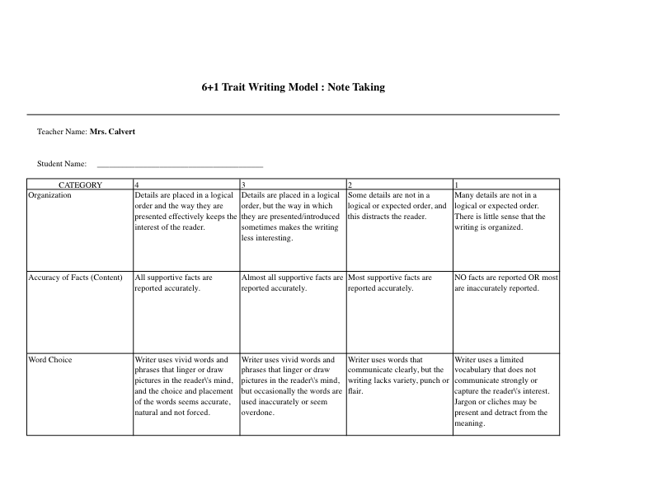

**Rubric II**

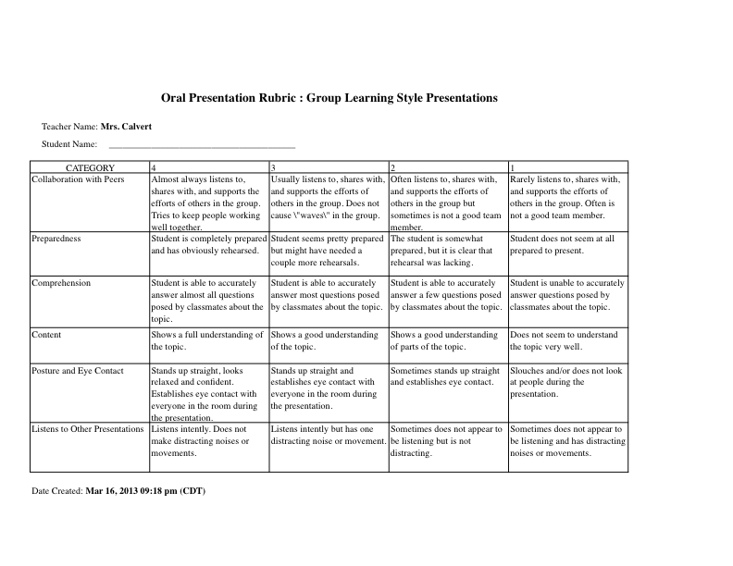

**Rubric III**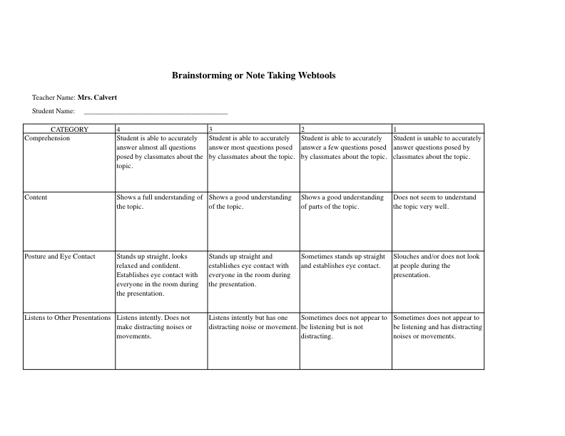

**Rubric IV**

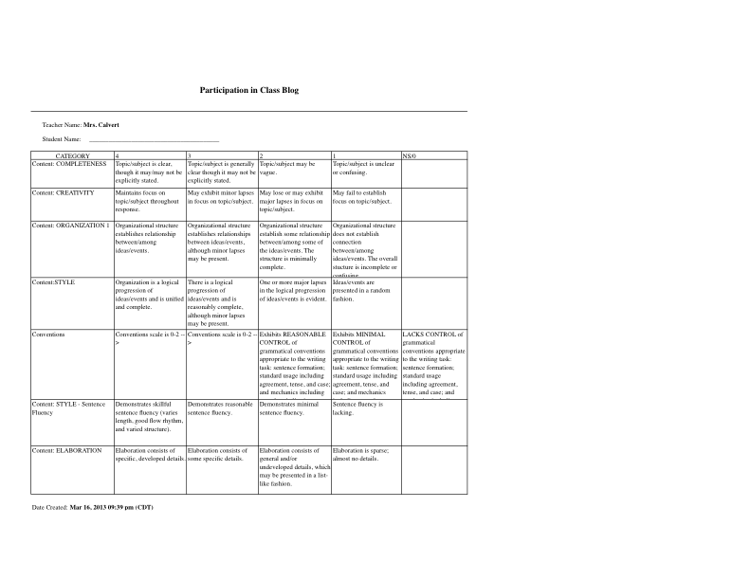**Instructional Materials I**

**Bubbl.Us Brainstorming**

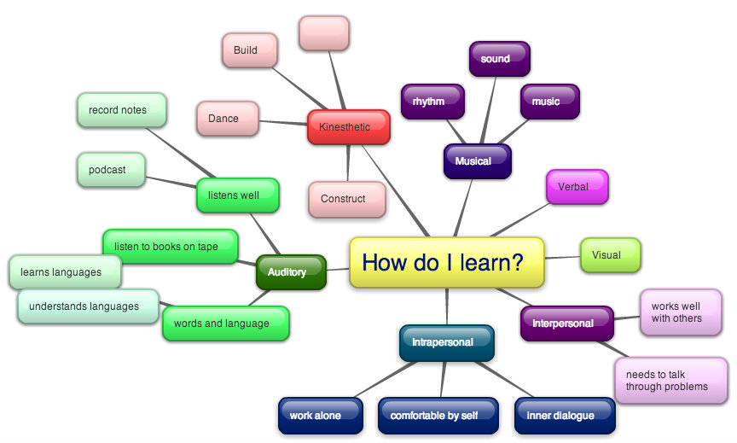

**Instructional Materials II**

**Howard Gardner’s Theory of Multiple Intelligences**

|  |
| --- |
| ***“An intelligence is the ability to solve problems,***  ***or to create products, that are valued within one or more cultural settings.” -- Howard Gardner***  ***FRAMES OF MIND (1983)*** |

**Verbal-Linguistic Intelligence**

***(“word smart” or “book smart”)***

**This intelligence involves the knowing which comes through language; through reading, writing, and speaking. It involves understanding the order and meaning of words in both speech and writing and how to properly use the language. It involves understanding the sociocultural nuances of a language, including idioms, plays on words, and linguistically-based humor.**

**If this is a strong intelligence for you, you have highly developed skills for reading, speaking, and writing and you tend to think in words. You probably like various kinds of literature, playing word games, making up poetry and stories, engaging in involved discussions with other people, debating, formal speaking, creative writing, and telling jokes. You are likely precise in expressing yourself and irritated when others are not! You love learning new words, you do well with written assignments, and your comprehension of anything you read is high.**

**Mathematical-Logical Intelligence**

***(“math smart” or “logic smart”)***

**This intelligence uses numbers, math, and logic to find and understand the various patterns that occur in our lives: thought patterns, number patterns, visual patterns, color patters, and so on. It begins with concrete patterns in the real world but gets increasingly abstract as we try to understand relationships of the patterns we have seen.**

**If you happen to be a logical-mathematically inclined person you tend to think more conceptually and abstractly and are often able to see patterns and relationships that others miss. You probably like to conduct experiments, to solve puzzles and other problems, to ask cosmic questions, and analyze circumstances and people’s behavior. You most likely enjoy working with numbers and mathematical formulas and operations, and you love the challenge of a complex problem to solve. You are probably systematic and organized, and you likely always have a logical rationale or argument for what you are doing or thinking at any given time.**

**Visual-Spatial Intelligence**

***(“art smart” or “picture smart”)***

**We often say “A picture is worth a thousand words!” or “Seeing is believing!” This intelligence represents the knowing that occurs through the shapes, images, patterns, designs, and textures we see with our external eyes, but also includes all of the images we are able to conjure inside our heads.**

**If you are strong in this intelligence you tend to think in images and pictures. You are likely very aware of object, shapes, colors, textures, and patterns in the environment around you. You probably like to draw, paint, and make interesting designs and patterns, and work with clay, colored markers, construction paper, and fabric. Many who are strong in visual-spatial intelligence love to work jigsaw puzzles, read maps and find their way around new places. You probably have definite opinions about colors that go together well, textures that are appropriate and pleasing, and how a room should be decorated. And, you are likely excellent at performing tasks that require “seeing with the mind’s eyes,” such as visualizing, pretending, imagining, and forming mental images.**

**Intrapersonal Intelligence *(“self smart” or “introspection smart”)***

**“self smart” or “introspection smart”). At the heart of this intelligence are our human self- reflective abilities by which we can step outside of ourselves and think about our own lives. This is the introspective intelligence. It involves our uniquely human propensity to want to know the meaning, purpose, and significance of things. It involves our awareness of the inner world of the self, emotions, values, beliefs, and our various quests for genuine spirituality.**

**If this intelligence is one of your strong points you may like to work alone and sometimes you may shy away from others. You are probably self-reflective and self-aware and thus you tend to be in tune with your inner feelings, values, beliefs, and thinking processes. You are frequently bearers of creative wisdom and insight, are highly intuitive, and you are inwardly motivated rather than needing external rewards to keep you going. You are often strong willed, self-confident, and have definite, well-thought out opinions on almost any issue. Other people will often come to you for advice and counsel.**

**Bodily-Kinesthetic Intelligence *("body smart" or "movement smart")***

**We often talk about “learning by doing.” This way of knowing happens through physical movement and through the knowing of our physical body. The body “knows” many things that are not necessarily known by the conscious, logical mind, such as how to ride a bike, how to parallel park a car, dance the waltz, catch a thrown object, maintain balance while walking, and where the keys are on a computer keyboard.**

**If you have strength in this intelligence area you tend to have a keen sense of body awareness. You like physical movement, dancing, making and inventing things with your hands, and role- playing. You probably communicate well through body language and other physical gestures. You can often perform a task much better after seeing someone else do it first and then mimicking their actions. You probably like physical games of all kinds and you like to demonstrate how to do something for someone else. You may find it difficult to sit still for long periods of time and are easily bored or distracted if you are not actively involved in what is going on around you.**

**Interpersonal *(“people smart” or “group smart”)***

**This is the person-to-person way of knowing. It is the knowing that happens when we work with and relate to other people, often as part of a team. This way of knowing also asks use to develop a whole range of social skills that are needed for effective person-to-person communication and relating.**

**If this person-to-person way of knowing is more developed in you, you learn through personal interactions. You probably have lots of friends, show a great deal of empathy for other people and**

**exhibit a deep understanding of other points of view. You probably love team activities of all kinds and are a good team member--you “pull your own weight” and often much more! You are sensitive to other people’s feelings and ideas, and are good at piggybacking your ideas on others’ thoughts. And you are likely skilled at drawing others out in a discussion. You are also probably skilled in conflict resolution, mediation, and finding compromise when people are in radical opposition to each other.**

2

**Naturalist Intelligence *(“nature smart” or “environment smart”)***

**The naturalist intelligence involves the full range of knowing that occurs in and through our encounters with the natural world including our recognition, appreciation, and understanding of the natural environment. It involves such capacities as species discernment, communion with the natural world and its phenomena, and the ability to recognize and classify various flora and fauna.**

**If the naturalist intelligence is one of your strengths you have a profound love for the outdoors, animals, plants, and almost any natural object. You are probably fascinated by and noticeably affected by such things as the weather, changing leaves in the fall, the sound of the wind, the warm sun or lack thereof, or an insect in the room. At a young age you were likely nature collectors, adding such things as bugs, rocks leaves, seashells, sticks, and so on to your collections. You probably brought home all manner and kinds of stray animals and today you may have several pets and want more. You tend to have an affinity with and respect for all living beings.**

**Musical-Rhythmic Intelligence *(“music smart” or “sound smart”)***

**This is the knowing that happens through sound and vibration. In the original research on the theory of multiple intelligences this intelligence was called musical-rhythmic intelligence. However, it is not limited to music and rhythm so I’m calling it auditory-vibrational, for it deals with the whole realm of sound, tones, beats, and vibrational patterns as well as music.**

**If you are strong in this intelligence area you likely have a love of music and rhythmic patterns. You are probably very sensitive to sounds in the environment; the chirp of cricket, rain on the roof, varying traffic patterns. You may study and work better with music in the background. You can often reproduce a melody or rhythmic pattern after hearing it only once. Various sounds, tones, and rhythms may have a visible effect on you--others can often see a change in facial expressions, body movement, or emotional responses. You probably like to create music and you enjoy listening to a wide variety of music. You may be skilled at mimicking sounds, language accents, and others’ speech patterns, and you can probably readily recognize different musical instruments in a composition.**

(Gardner, 1983)

# Instructional Materials III

# 100 Helpful Web Tools for Every Kind of Learner

[www.collegeathome.com/blog/2008/06/10/100-helpful-web-tools-for-every-kind-of-learner/](http://www.collegeathome.com/blog/2008/06/10/100-helpful-web-tools-for-every-kind-of-learner/)

# 100 Helpful Web Tools for Every Kind of Learner

Posted on 06.10.2008

For those unfamiliar with the term, a [learning style](http://yvonnewalus.blogspot.com/) is a way in which an individual approaches learning. Many people understand material much better when it is presented in one format, for example a lab experiment, than when it is presented in another, like an audio presentation. Determining how you best learn and using materials that cater to this style can be a great way to make [school](http://www.collegeathome.com/) and the entire process of acquiring new information easier and much more intuitive. Here are some great tools that you can use to <a href=">cater to your individual learning style, no matter what that is.

### ****Visual Learners****

Visual learners learn through seeing and retain more information when it's presented in the form of pictures, [diagrams](http://strategicstoryboarding.com/wp), visual presentations, textbooks, handouts and videos. Here are some Web resources that cater to those needs.

**Mind Mapping**

Get your ideas charted out in a visual format with these easy-to-use online brainstorming and organizational tools.

1. [**Bubbl.us**](http://www.bubbl.us/)**:**This flash-based mind mapping tools allows you to chart out your thoughts in a colorful format, share them with friends or embed them in blogs, websites and emails.
2. [**Free Mind**](http://freemind.sourceforge.net/wiki/index.php/Main_Page)**:**Mind mapping is easy and free with this Java tool. You'll be able to manage your [class notes](http://www.collegeathome.com/), lay out a paper and more completely online.
3. [**WiseMapping**](http://www.wisemapping.com/c/home.htm)**:**You can access your mind maps from anywhere with this online tool. You can lay out words, pictures, ideas and more easily with WiseMapping.
4. [**Mindomo**](http://www.mindomo.com/)**:**Premium versions of this mind mapping tool come at a cost, but you can get access to the basic version for free. It allows you to add links, pictures and text to mind maps and share them over the net.
5. [**DeepMehta**](http://www.deepamehta.de/)**:**This mind mapping tool is built around the idea of knowledge management and cognitive psychology. The open source tool allows sharing, emailing and even contains an embedded calendar.
6. [**MindMeister**](http://www.mindmeister.com/)**:**Collaborate with your [Mind42](http://mind42.com/): The name of this tool represents "for two", and is indicative of the collaborative nature of this mapping tool. It can make it easy to keep track of your ideas, share them with friends and teachers and take them with you no matter where you are.
7. [**RecallPlus**](http://www.recallplus.com/)**:**Students can organize their notes, create flashcards, make use of 3D tools and more in this great mind mapping tool.
8. [**Mapul**](http://www.mapul.com/)**:**This mind mapping program has basic and premium levels and allows users to map not only text but images and hyperlinks as well.
9. [**DebateMapper**](https://debatemapper.com/sf/home.aspx)**:**If you're struggling to understand a debate for your [classes](http://www.collegeathome.com/) try creating a [visual](http://eideneurolearningblog.blogspot.com/2005/02/visual-learning-style-as-kaleidoscope.html) representation with this great mapping tool.
10. [**CMapTools**](http://cmap.ihmc.us/)**:**CMapTools is free for students to use and allows them to create and share all kinds of knowledge maps.
11. [**Thinkature**](http://thinkature.com/)**:** This site allows real-time collaboration on flow charts, diagrams and mind maps with features that include color organization and freehand drawing.

**Charting and Diagrams**

Love to put information into charts and diagrams? These tools can help you do that.

1. [**Gliffy**](http://www.gliffy.com/)**:** Gliffy makes it easy to lay out ideas in flow charts and diagrams or to create floor plans and technical drawings to help you better [visually understand](http://www.presentationzen.com/presentationzen/2006/06/the_power_of_th.html) information.
2. [**FlowChart**](http://www.flowchart.com/)**:**Create great flow charts for your classes using this online tool, which comes complete with drawing tools and objects as well as collaborative tools.
3. [**DrawAnywhere**](http://www.drawanywhere.com/)**:**This online program allows you to create diagrams and flow charts to represent all kinds of information. Best of all, you can log in from anywhere to get access to your diagrams.
4. [**AjaxSketch**](http://us.ajax13.com/en/ajaxsketch/)**:**This web-based drawing tool makes it easy to not only create flow charts and diagrams but to do freehand drawing as well and you can use it right from Firefox.
5. [**XML/SWF Charts**](http://www.maani.us/xml_charts/index.php)**:**Those familiar with XML will be able to turn their data into colorful and useful charts with this downloadable tool.
6. [**yEd**](http://www.yworks.com/en/products_yed_about.htm)**:**Is a very powerful graph editor and creation tool that can be used to quickly and effectively generate drawings and to create easily read and laid out graphs and diagrams.
7. [**Graphviz**](http://graphviz.org/)**:**If you've got a lot of information about the structure of a website or anything else for that matter, this tool can help you to easy map it out into a graph or network.
8. [**Kivio**](http://www.koffice.org/kivio)**:**Kivio easy to use diagramming and flowcharting application that is part of the KOffice suite of programs. It comes with features to network diagrams, create organization charts, build flowcharts and more.
9. [**Project Draw**](http://draw.labs.autodesk.com/ADDraw/draw.html)**:**This program is a feature-rich web-based vector drawing application that will allow you to create diagrams and graphs of any kind of information as well as making a variety of other kinds of drawings.
10. [**Best 4C**](http://www.best4c.com/jsp/index.html?language=en)**:**This Web-based tool allows you to create and share charts from anywhere, making it easier than ever to diagram and draw your ideas.
11. [**LovelyCharts**](http://www.lovelycharts.com/)**:**Charts created through this tool really can be lovely with full color capabilities and loads of graphics.

**Videos** **and Photos**

Find everything you'll need to learn through videos and pictures with these tools.

1. [**Google Video**](http://video.google.com/)**:**Google Video is chock full of educational videos that can help explain everything from how to use Second Life to learn to explanations of psychological illnesses.
2. [**YouTube College**](http://youtube.com/school_main)**:**Sign up with your individual college and share videos with fellow students on this College-based version of YouTube. You can post your own visual notes and slides or look at those of others.
3. [**Picasa**](http://www.picasa.com/)**:**Picasa is Google's answer to photo sharing and you can upload images from an art history or anatomy class and study them from anywhere on the Web.
4. [**Flickr**](http://www.flickr.com/)**:**This social networking and photo posting site can be a great way to share images from a class with your [classmates](http://www.collegeathome.com/) or look for images to back up your notes.
5. [**Scooch**](http://scooch.gr0w.com/)**:**Scooch is a Web-based slide show program that will allow you to post photos and make slide shows that you can share with others over the Web.
6. [**Perseus Digital Library**](http://www.perseus.tufts.edu/)**:**In need of visual representations of manuscripts or sculptures from ancient Rome and Greece? You can find tens of thousands on this online library and database.
7. [**Teachertube**](http://www.teachertube.com/)**:**Teachertube is a great place to find instructional videos on just about everything. You can learn about the formation of mountains, world history and economics on this useful educational site.
8. [**Screencast-o-Matic**](http://data.screencast-o-matic.com/images/som2.gif)**:**Create a video or photo of your screen with this helpful online tool. It can be a great way to remember how to do tasks on the computer or just to share images online.
9. [**Jing Project**](http://www.jingproject.com/)**:**This tool allows you to snap a photo of your desktop, make recordings of your activities and email or IM them to anyone.
10. [**Visuwords**](http://www.visuwords.com/)**:**Text dictionaries don't always give visual learners the explanations they need. This dictionary is graphically based, making it easy to see what concepts or ideas are represented.
11. [**KartOO**](http://www.kartoo.com/)**:**Along those same lines, Kartoo is a visual search engine, giving you results laid out in a networked chart so it's easy to see how topics relate.

### [Auditory Learners](http://www.collegeathome.com/school-reviews/)

Auditory learners do best in classes where listening is a main concern. [These learners](http://edorigami.wikispaces.com/ICT%2Band%2Bthe%2BAuditory%2BLearner) prefer verbal lectures and discussions. Auditory learners can get a leg up on their learning with these Web tools.

**Podcasts**

Get all kind of supplementary education materials through these great podcast tools.

1. [**ProfCasts**](http://www.profcast.com/public/index.php)**:**Turn a PowerPoint presentation into a useful and portable podcast using this tool. It can be a great way to put class materials into a format you can bring with you anywhere.
2. [**Moodle**](http://moodle.org/)**:**Post and share podcasts with an interactive online community using Moodle. You can not only post your own podcasts but get access to those of others that could provide educational value to you.
3. [**First Class**](http://www.firstclass.com/)**:**This collaboration and communication software offers a podcast publishing feature that can be great for educational purposes.
4. [**Podomatic**](http://www.podomatic.com/mix)**:**Find, share and publish your podcasts through Podomatic. You can search for existing podcasts that may cover topics you're researching or that are relevant to your classes.
5. [**Podcast.net**](http://www.podcast.net/)**:**Podcast.net provides a huge listing of podcasts from all over the Web. You'll be able to find just about anything you need in an easy, audio format.
6. [**Educational Podcast Network**](http://www.epnweb.org/index.php)**:**Narrow your search for podcasts down to those dedicated to education. You can learn about everything from math to dance right on your iPod.
7. [**PoducateMe**](http://www.poducateme.com/)**:**Don't know the first thing about podcasting or how you can use it to make education a little easier? This site has all the information you need.

**Presentation Tools**

Put your notes or classroom information into an audio format with these handy apps.

1. [**Zoho Show**](http://show.zoho.com/jsp/zoho_login.jsp)**:**This great online tool allows you to create, edit and share presentations online making it easy to create interactive homework assignments or to organize your notes in an audio-visual format.
2. [**Eyespot**](http://www.eyespot.com/)**:** Users can create video mixes online and share them with others on this site and can even add effects to their graphics and music.
3. [**Thumbstacks**](http://www.thumbstacks.com/)**:**Thumbstacks allows users to create a web-based presentation or slide show and then share it with others.
4. [**SlideShare**](http://slideshare.net/)**:**This site takes more of a networked approach to creating presentations allowing you to post your presentations and browse those of other users.
5. [**Empressr**](http://www.empressr.com/)**:**You can access your organized class materials or projects from anywhere with this tool and share them with friends and other classmates easily.
6. [**ThinkFree Show**](http://www.thinkfree.com/)**:**If you are using PowerPoint to organize your class notes into a more visual and audio conducive format then you can take advantage of this site which makes it easy to take them to the Web.
7. [**AuthorStream**](http://www.authorstream.com/)**:**Another PowerPoint centered program, AuthorStream makes it simple to upload and share your presentations.
8. [**Toufee**](http://toufee.com/)**:**If Flash is more your style you can use this online tool which gives you the tools needed to publish and play flash presentations and movies.
9. [**PhotoStory 3**](http://www.microsoft.com/downloads/details.aspx?FamilyID=92755126-a008-49b3-b3f4-6f33852af9c1&DisplayLang=en)**:**Make your slides for class a little more interesting with this free program from Microsoft. You can add special effects or your own voice narration.

**Audio Tools**

Listen and edit your sounds and music with these tools.

1. [**Jamglue**](http://www.jamglue.com/)**:**Mix and edit your audio clips with this online tool and when you're done, share the finished product with other online visitors in a YouTube like format.
2. [**Audacity**](http://audacity.sourceforge.net/)**:**One of the most popular free audio editors out there, audacity is multi-featured and allows users to record and edit in all kinds of formats.
3. [**Wave Surfer**](http://www.speech.kth.se/wavesurfer)**:**Visualize and manipulate sounds with this free and customizable tool.
4. [**Looplab**](http://www.looplabs.com/)**:**Create and manipulate short loops and phrases with this great sound editing tool.
5. [**LAME**](http://sourceforge.net/projects/lame)**:**This open source tool makes it easy to encode and manipulate MP3s.

**Text Readers**

Understand material better when it's [read out loud](http://trainingpd.suite101.com/blog.cfm/tips_for_auditory_learners)? These Web tools can do that for you.

1. [**Adobe Acrobat Reader**](http://adobe.com/)**:**You may not know this, but Adobe Reader has a feature that will allow the contents of the document to be read out loud. It can be a great way for the more auditorially inclined to get through readings.
2. [**Read Please**](http://www.readplease.com/)**:**Cut and paste text or type it directly into the input form on this site and the program will read it to you. It can be a very useful tool for making sure essays and projects are written correctly.
3. [**Text Reader**](http://www.text-reader.com/)**:**Here you'll find a tool that will give you audio for any text you feed into it.
4. [**Expressivo**](http://say.expressivo.com/)**:**This simple text reader will give you a variety of audio readings when you paste or type text into the entry form.
5. [**ItCanSay**](http://itcansay.com/)**:**This site has a great online text reader and can also give you some help pronouncing difficult words that aren't said like they're spelt.
6. [**Midomi**](http://www.midomi.com/)**:** While not quite a text reader, this tool couldn't be left out of this list. It's a search engine that is based on sound rather than text. It can be a more intuitive way to find things if you respond better to sounds.

**Audio Books**

Those who have trouble retaining information from printed words can listen to their assigned reading instead with help from these sites.

1. [**LibriVox**](http://librivox.org/)**:**This site provides free audiobooks for books in the public domain and has numerous titles. If you don't find what you want, see if you can volunteer to create a recording of the book yourself.
2. [**History and Politics Out Loud**](http://www.hpol.org/index.html)**:**Here you'll find speeches, historical information and more in an audio format, making it easier to take in and absorb for the auditory learner.
3. [**Audible**](http://www.audible.com/adbl/site/homepage/AnonHome.jsp?BV_UseBVCookie=Yes)**:**This subscription site allows visitors to download from thousands of audio books, both best sellers and classics making it easy to find what you need for class.
4. [**Project Gutenburg**](http://www.gutenberg.org/wiki/Main_Page)**:**Books that are no longer under copyright can be found here and there is a special section for audio books, both read by computers and by humans.
5. [**Free Books.org**](http://www.free-books.org/)**:**If your class is reading an older text you may be able to find a free version of it to listen to on this site. It contains recordings of numerous out of copyright books.

### ****Kinesthetic Learners****

[Kinesthetic learners do best when they interact and touch things](http://www.collegeathome.com/open-courseware/). They prefer a hands-on approach to [learning](http://daniniven.blogspot.com/2007/03/learning-styles-and-ict.html) and enjoy interacting with classroom materials and those around them. These tools can help keep these inquisitive learners busy.

**Note Taking Tools**

No matter what you're reading or watching you can make it more interactive by taking notes and these tools can help.

1. [**MyNoteIT**](http://www.mynoteit.com/)**:** This great tool allows students to take and store their notes online, edit them with the help of classmates, look up words or terms you don't understand and keep track of things you need to do.
2. [**Google Docs**](http://docs.google.com/)**:** With this program from Google you can take notes online, save them, and even send them to your peers for collaboration.
3. [**Notely**](http://www.notely.net/)**:** Keep your class notes, to-do lists and more organized and easy to access with this site.
4. [**NoteMesh**](http://notemesh.com/)**:** This site allows students from the same class to share notes by creating a wiki, making it easy and practical to work together.
5. [**Stu.dicio.us**](http://stu.dicio.us/)**:** Here, students are able to actively organize their class materials, take and store notes, share information and even link to online reference sites.
6. [**ShortText**](http://www.shorttext.com/)**:**This is a very simple tool for taking notes online. Simply enter your text, hit save, and you've got an online note you can revisit anytime you like.
7. [**YourDraft**](http://www.yourdraft.com/)**:**Take notes with this rich text editor and share and save them online.
8. [**Stickkit**](http://www.stikkit.com/)**:**Get an intelligent sticky note with this great online program. It looks at the text on your notes and can recognize important dates, bookmarks, emails and more, organizing them for you and making it easy to stay on top of everything.
9. [**SyncNotes**](http://www.syncnotes.com/)**:**If you use a PDA this can be a great way to keep your notes accessible on both your main computer and your portable device.
10. [**JotCloud**](http://www.jotcloud.com/index.php)**:**If you're the type that loves to put sticky notes all over everything then you'll enjoy this online note taking tool. It allows you to create clouds of stickies anywhere you need them.
11. [**NoteCentric**](http://www.notecentric.com/)**:**Store and share your classroom notes with this innovative site. It keeps your notes organized so you can reference them later and you can easily access it through a Facebook account.

**Bookmarking**

Mark references for later while you're researching with these tools.

1. [**del.icio.us**](http://del.icio.us/)**:**This online tool makes it easy to mark sites you find interesting to use for later research or to send to friends and project partners.
2. [**Clipmarks**](http://www.clipmarks.com/)**:**Don't waste time searching through webpages you've already read to find the content you needed. Instead, clip it out this this tool. You can clip and email bits to yourself as you go making online research more active.
3. [**Wizlite**](http://wizlite.com/)**:**Don't just save online material for later, highlight and tag it just like you would a real book with this great online tool.
4. [**i-Lighter**](http://www.i-lighter.com/)**:**Help make online reading a little more hands on with this highlighting program. It allows you to mark parts of online text you found interesting or want to revisit later.
5. [**Web-Chops**](http://www.web-chops.com/)**:**Web-Chops allows you to clip out any part of a webpage then save and share these clips. It can be a great way to [study for tests](http://www.studyskillsblog.com/learning-strategies-for-kinesthetic-learners) or prepare for papers in a more interactive fashion.
6. [**Furl**](http://www.furl.net/)**:**This social bookmarking site makes it easy to keep track of webpages you were interested in, share them with classmates and keep them organized for research.
7. [**Ma.gnolia**](http://ma.gnolia.com/)**:**Search through sites others have bookmarked as interesting or use the site to highlight your own information from the Web and keep it in an easy to find place.
8. [**Blinklist**](http://www.blinklist.com/)**:**Make lists of sites that are relevant to whatever you're working on with Blinklist. If you have a blog, you can even have the links appear automatically on it, making them super easy to access later.

**Interaction**

Get involved with the material with these online applications.

1. [**Flash Card Machine**](http://www.flashcardmachine.com/)**:** This site allows you to create web-based flash cards to study the information you have for class using text and pictures.
2. [**Quia**](http://www.quia.com/)**:** With Quia, you'll be able to create your own online quizzes and educational games to help you study your materials in a more interactive fashion.
3. [**Quizlet**](http://quizlet.com/)**:**Quizlet makes it easy to study things like vocabulary words with it's online study tools. You can make quizzes, use your friend's or browse existing flashcards on the site.
4. [**Pauker**](http://pauker.sourceforge.net/)**:**This open source program will test your short and long term memory with a system that makes it easy to create and reuse flashcards and quizzes.
5. [**Learner.org Interactives**](http://www.learner.org/interactives)**:**Need a more interactive explanation of a concept from class? You'll find dozens of educational ones here that can help explain geology, [pharmacy](http://www.pharmacy-technician-certification.com/), chemistry, [math](http://wildaboutmath.com/2007/11/06/how-kinesthetic-folks-learn-math)and more.

**Collaboration**

These chatting and networking tools can make it easy to interact with classmates and friends.

1. [**Meebo**](http://wwwm.meebo.com/index-en.html)**:**This website allows students to IM from anywhere, even computers without the software installations for major programs like AIM, Yahoo!, MSN and more.
2. [**Campfire**](http://www.campfirenow.com/)**:** Here students can create password protected chat rooms to discuss their assignments, collaborate on projects or just chat. Best of all, you won't need to install a thing.
3. [**CollegeRuled**](http://collegeruled.com/)**:** Students can set up class message boards, create to-do lists and interact with classmates on this site.
4. [**Campusbug**](http://www.campusbug.com/)**:** This site provides a social learning network where students can interact and chat with each other while asking questions and getting answers about class materials.
5. [**Facebook**](http://www.facebook.com/)**:**One of the most popular social network sites for students, Facebook provides a place where classmates can come together to chat about assignments, keep up with their lives and post links to sites, videos and photos.
6. [**Backpack**](http://www.backpackit.com/)**:**Backpack allows students to organize their notes, to-do lists and calendars while sharing information and working with classmates.
7. [**The Campus Center**](http://www.thecampuscenter.com/)**:**Students can get together and network on this site and also have access to note taking and spreadsheet programs.
8. [**JotSpot**](http://www.jotspot.com/)**:** Working in a group just became easier with this online wiki tool that allows students to share notes, project ideas and information in an easily accessible format.
9. [**WebBrush**](http://www.stanfy.com/dev/webbrush)**:** Collaborate in a fun and creative way with this tool that lets students send drawings and graphics to one another.
10. [**Grouptivity**](http://www.grouptivity.com/)**:** This site allows students to use email to start a group discussion about class projects and assignments or just to complain about their professors.

© 2013 College@Home | All Rights Reserved. (2008)

References:

Brooks, J., & Brooks, M. (1993). Becoming a constructivist teacher. In *In Search of Understanding: The Case for Constructivist Classrooms* (Revised ed.). Retrieved from http://www.pbs.org/teacherline/courses/inst335/docs/inst335_brooks.pdf

Gardner, H. (1983). *Frames of Mind*. Retrieved from http://aplus-schools.uncg.edu/multipleintelligences.pdf

Gardner, H. (1991) *The Unschooled Mind: How Children Think and How Schools Should Teach,*New York: Basic Books

Howlett, J., Jonassen, D., & Marra, R. (2012). *Meaningful learning with technology*. (4th ed., p. 2). Boston: Pearson Learning Solutions.

*100 tools for every type of learner*. (2008). Retrieved from www.collegeathome.com/blog/2008/06/10/100-helpful-web-tools-for-every-kind-of-learner/